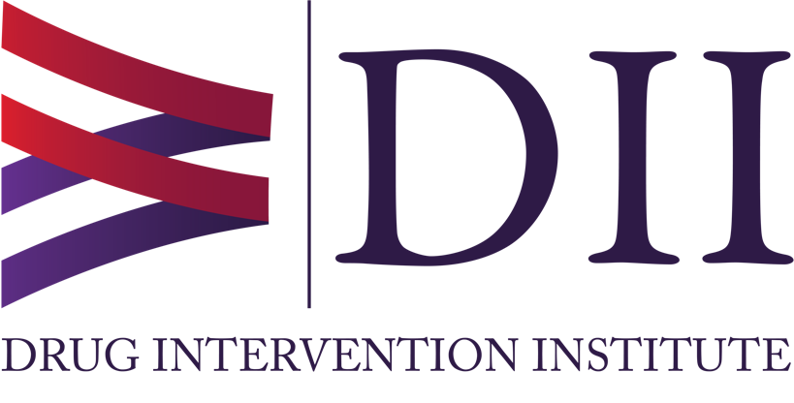
Vice President
Drug Intervention Institute, Inc.

Position Summary:
The Drug Intervention Institute seeks a Vice President. This position will work closely with the Institute President in the operational management of the Institute and will oversee and manage the Institute’s outreach and programming including day-to-day supervision and guidance of Institute staff.

This is a full-time (in office) position that reports directly to the Institute’s President. Periodic weekend and evening work may be required. Travel expenses are paid/reimbursed. Salary is commensurate with experience. Heath care stipend available.

Qualifications:
- A minimum of a bachelor’s degree required.
- Deep commitment to the mission and experience and understanding of evidenced-based and innovative approaches to SUD response required.
- Excellent written and oral communication skills required.
- Experience managing programming and/or operational budgets required.
- Previous experience with learning management systems for delivering continuing education preferred as well as experience managing CEUs preferred.
- Previous work as an administrator preferably at the director level or higher within a health-related non-profit preferred.
- Grants management and reporting experience preferred.
- Knowledge of state opioid response monies and opioid settlement funding opportunities preferred.

Duties and Responsibilities:

- Oversee and Manage the Institute’s Outreach and Programming Including Day-to-Day Supervision and Guidance of Institute Staff:
  - Under the direction of the President, oversee all programming, outreach, and growth of the Don’t Keep Rex Around Medication Safety Program/Harm Reduction Campaign.
  - Represent the Institute by serving on regional and statewide task forces and committees when requested/needed.
  - Coordinate and manage the Institute’s statewide naloxone distribution, education, and management including an online course.
  - Oversee activities related to grants the Institute receives and assist with grant writing, reporting, and invoicing.
  - Manage, guide, and coach a programming and Institute staff of 5-15 persons including full-time staff and contract employees.
  - Oversee the Institute’s fentanyl awareness outreach, education, and distribution of testing strips.
  - On behalf of the President, attend local, regional, and national meetings as a representative a primary spokesperson for the Institute as requested.
  - Work with the Institute President and Director of ONEbox Outreach and Distribution on sales and marketing plans related to the ONEbox product.
  - Host the Institute’s monthly television program on the WV Library Television Network/PBS.

- Assist the President with the Operational Management of the Institute:
  - Work in consultation with the President (and other key team members) to identify future funding streams for Institute programs and outreach.
  - Develop in concert with the Institute President (and other key team members), sustainability, marketing, and sales plans including financial forecasts.
  - Serve as a liaison with Jobs and Hope West Virginia, including assisting with registration, reporting, and any other tasks as needed.
  - Manage and oversee the Institute’s marketing plan, learning management system, and website in coordination with consultants.
  - Attend regular quarterly board meetings and present when requested on Institute progress.
  - Make recommendations for programmatic and policy changes including drafting standard operating procedures, employment policies, and workflow documents.
  - Draft press releases on Institute programs and activities under the consultation of the President.
  - Serve as a spokesperson for the Institute with local news stations and organizations when requested by the Institute President.

Applications should be sent to Ms. Mia Manfredi, Executive Assistant at: mia@wvdii.org. Applications should include a cover letter, a curriculum vita, and the names, addresses and phone numbers of three (3) references. References will not be contacted without notification of the applicant.

