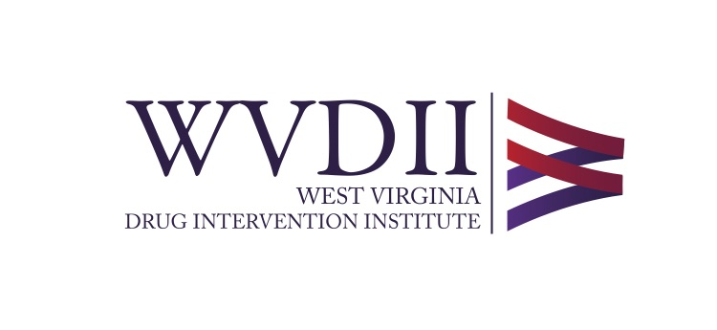
Outreach and Education Coordinator
West Virginia Drug Intervention Institute, Inc.

JOB SUMMARY
The West Virginia Drug Intervention Institute, Inc. seeks an outreach and education coordinator to support the efforts of the Institute in communities in West Virginia and Kentucky while carrying out the Appalachian Regional Commission INSPIRE grant. The WVDII will be collaborating with outside organizations to build a recovery workforce in high-risk counties in West Virginia and Kentucky. An essential function of this project is to employ outreach and education coordinators to educate community members on substance use disorder, stigma, naloxone administration (while deploying the ONEbox™) and providing resources for treatment, recovery, childcare, and other barriers that may affect community members abilities to find employment or to obtain treatment for substance use disorder.

Essential Functions of the Position:
- Serve as the outreach and education coordinator for one or more assigned counties/communities.
- Work in tandem with local police departments and the Police Assisted Addiction and Recovery Initiative (PAARI) to educate community members about the use of naloxone, overdose prevention, and treatment and recovery resources.
- Participate in PAARI’s recovery Corp training and mentorship program.
- Collaborate with the West Virginia and/or Kentucky Office of Drug Control Policy.
- Work with community members and local law enforcement to determine the best locations for naloxone and ONEbox™ placement.
- Provide training on the ONEbox™ to employees and volunteers of the selected locations.
- Prepare communications such as memos, emails, invoices, and other correspondence as directed by supervisor.
- Obtain certification through the Connecticut Community for Addiction Recovery (CCAR) via PAARI.
- Connect community members in the assigned county to treatment and recovery resources and employment resources as needed.
- Coordinate and facilitate meetings as directed and needed.
- Collect data related to training, ONEbox deployment, resources provided, and naloxone distribution and provide reports to supervisor on a monthly basis and as requested.
- If living in West Virginia, participate in West Virginia Jobs and Hope program.
- Occasional travel and weekend representation for meetings, conferences, and public health events furthering the mission of the Institute.
- Always maintain confidentiality.
- All other duties as assigned by the Institute President or Vice President.

Skills/Qualifications:

- A high school diploma or GED is preferred
- Excellent communication skills, both written and verbal required
- Excellent phone skills required
- Proficiency in Microsoft Office Products such as Word, PowerPoint and/or Excel required
- Professional, positive, and pleasant demeanor required
- Punctuality and professionalism required
- Ability to work independently is required
- Valid drivers license is required
- Preference given to applicants in long term recovery (at least 2 years)
- Drug screenings upon hiring and randomly throughout employment are required

The Outreach and Education coordinator will report directly to the Vice President.

Applicant must live in one of the following counties:
- McDowell County, West Virginia
- Logan County, West Virginia
- Cabell County, West Virginia
- Raleigh County, West Virginia
- Mercer County, West Virginia
- Kanawha County, West Virginia
- Mason County, West Virginia
- Mingo County, West Virginia
- Estill County, Kentucky
- Knott County, Kentucky
- Lawrence County, Kentucky
- Madison County, Kentucky
- Floyd County, Kentucky
- Garrard County, Kentucky
- Letcher County, Kentucky

The mission of the West Virginia Drug Intervention Institute is to reduce deaths in West Virginia from opioid and drug abuse through prevention, education and outreach. The Institute is housed in a central downtown location in West Virginia’s state capital city.

WV DII is an EOE and a recovery friendly work environment.

Job Type: hours per week will vary, with an average 30 hours per week, Monday-Friday. Occasional evening or weekend hours may be needed. This position is primarily remote. This position is grant funded and is expected to continue for 18 months.

Pay: $15.00 per hour.

Applications should be sent to Ms. Mia Manfredi, Budget and Office Manager at: mia@wvdii.org. Applications should include a cover letter, a curriculum vita, and the names, addresses and phone numbers of three (3) references. References will not be contacted without notification of the applicant.

