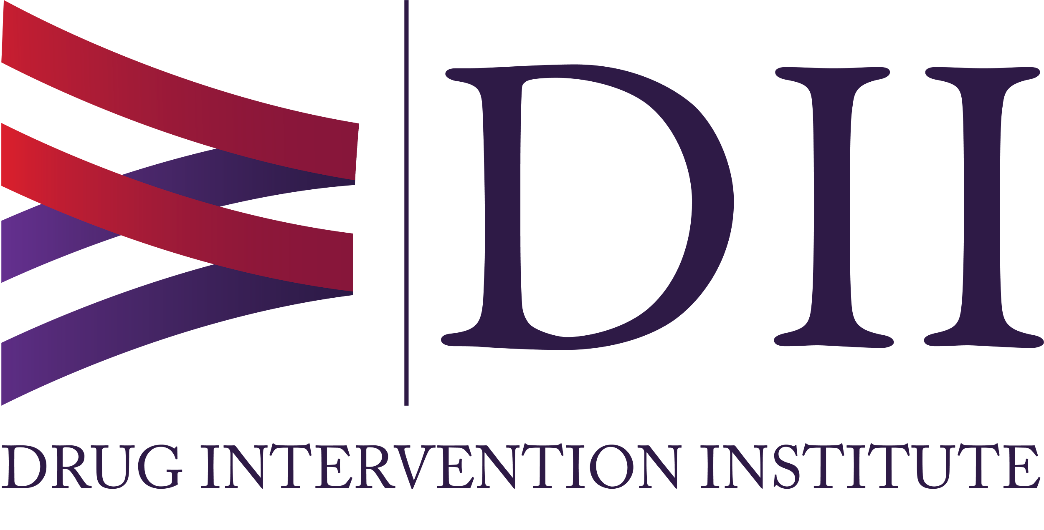

Outreach and Education Coordinator (Knox County, TN)
West Virginia Drug Intervention Institute, Inc.

JOB SUMMARY
The West Virginia Drug Intervention Institute, Inc., is seeking a part-time Outreach and Education Coordinator for Knox County, TN, to support our efforts in local communities as part of the Appalachian Regional Commission's INSPIRE grant. The WVDII will work with external organizations to develop a recovery workforce in at-risk counties. A key part of the outreach and education coordinator’s role is to educate community members about substance use disorder, reduce stigma, train in naloxone administration (while deploying the ONEbox), and provide resources for treatment, recovery, and other barriers that might prevent students or community members from getting treatment for substance use disorder. Preference will be given to applicants with successful work experience in non-profit or corporate office environments and those with college experience.

Essential Functions of the Position:

- Serve as the outreach and education coordinator for the assigned county.
- Work on college campuses and with faculty, staff, and administration to develop support for students, as well as in tandem with local police departments, Quick Response Teams (QRTs), and the Police Assisted Addiction and Recovery Initiative (PAARI) to educate the community about the use of naloxone, overdose prevention, treatment, and recovery resources.
- Participate in PAARI/WVDII training and mentorship program.
- Collaborate with the TN and Office of Drug Control Policy and local county coalitions (attending coalition meetings).
- Work with community members and local law enforcement to determine the best locations for naloxone and ONEbox™ placement.
- Provide training on the ONEbox™ to employees and volunteers of the selected locations.
- Prepare communications such as memos, emails, invoices, and other correspondence as directed by the supervisor.
- Obtain certification through the Connecticut Community for Addiction Recovery (CCAR) via PAARI if not already certified.
- Connect community members in the assigned county to treatment and recovery resources, as well as employment resources, as needed.
- Coordinate, facilitate, and attend meetings as directed and needed.
- Adhere to the code of ethics for PRSS at all times; Participate in training and the certification process.
- Provide outreach and early intervention to individuals in the pre-contemplation and contemplation stages of change, as well as those experiencing symptoms of a recurrence of symptoms.
- Facilitate recovery-oriented group and individual supportive intervention services with students and community members (as approved by direct supervisor);
- Assist individuals in crises involving social, emotional, health, and other problems.
- Assist individuals served with setting goals, creating and monitoring individualized change/recovery plans, and working toward developing skills to attain and sustain recovery;
- Collect data related to training, ONEbox deployment, resources provided, and naloxone distribution, and provide reports to the supervisor every month and as requested.
- Occasional travel and weekend representation for meetings, conferences, and public health events furthering the mission of the Institute; mileage will be reimbursed.
- Always maintain confidentiality.
- All other duties as assigned by the Institute President or Grant and Program Administrator. The Outreach and Education coordinator will report directly to the Grant and Program Administrator.

Skills/Qualifications:
- A high school diploma or GED is required
- Excellent written and verbal communication skills are required, as you will be contacting businesses regarding the ONEbox.
- Proficiency in Microsoft Office Products such as Word, PowerPoint, and Excel is required for reporting.
- Professional, positive, and pleasant demeanor required
- Punctuality and professionalism are required
- The ability to work independently is required
- A valid driver's license and reliable transportation are required, as you will be traveling to various counties and communities on a weekly basis.
- Personal history with a substance use disorder and have a stable recovery for a period of a minimum of two years.
- Must not have had intensive behavioral health treatment involvement in the last six months
- No legal involvement within the last six months; a criminal background check is required.
- Must be able to work with people of all backgrounds and maintain sensitivity to the problems of the homeless, mental health, and substance abuse issues.
- Knowledge, experience, and understanding of mental illness and substance abuse.
- Knowledge of available treatment and recovery resources, including both medically assisted treatment and abstinence-based programs, as well as mental health services/resources in the surrounding community
- Must have an understanding of and support each individual’s unique pathway to recovery
- Drug screenings are required upon hiring and randomly throughout employment.

Worksites are geographically based on the county where we are approved to work, as instructed by our grant from the ARC. You must be able to travel and provide prevention outreach to this specific region. At times, you may be required to travel outside your area for regional or statewide conferences, which will be reimbursed. Information will be provided to the employee as soon as possible regarding any upcoming travel related to employment.

WV DII is an EOE and a recovery-friendly work environment. Those in long-term recovery are encouraged to apply.

Job Type: Hours will vary, with an average of 25per week, Monday through Friday. Occasional evening or weekend hours may be needed. Travel to our Charleston, WV office will be required for occasional in-person meetings. All work-related travel can be reimbursed. This position is grant-funded and is expected to continue for 18 months. Please note that this position is funded by a grant and is limited in duration based on the availability and length of those funds. It should not be viewed as a permanent appointment.

Pay: $15.00 per hour. Part-time employment.

Applications should be sent to Micki Ruppert at Micki@wvdii.org. Applications should include a cover letter, a resume, and the names, addresses, emails, and phone numbers of three (3) references. References will not be contacted without the applicant's prior notification.

